Additional documentation for PavementEye Project
Pavement Eye is an intelligent system designed to automatically detect the location and types of pavement cracks using deep learning techniques in a cost-effective and efficient manner. The system leverages advanced data engineering practices to build a high-performance, real-time data streaming pipeline, ensuring rapid processing and analysis of large volumes of roadway imagery. Furthermore, the application integrates seamlessly with OpenStreetMap (OSM), enabling enhanced spatial analysis and visualization of pavement conditions within a broader geographic context.

This document includes additional information about the project such as KPIs, Timeline and Roles of team members.
KPIs
KPI | Description | Status/validation
Crack detection accuracy | The system can achieve accuracy of mAP of 0.5 or higher in Egyptian roads | Achieved with mAP of 0.55 after fine tuning on EGY_PDD dataset with more than 15K images of Egyptian roads.
System performance | The system can handle 1 image per second for the whole pipeline cycle. From capturing till image storage. | Achieved successfully and validated via Kafka UI and spark logging. Also enhanced more by replacing normal APIs with web sockets for duplex connection between backend and flutter application.
Correct geolocation analysis | The system can correctly get location (latitude and longitude) and assign the crack accurately to its roads and district (منتزة, رمل, عجمي, الخ) | Achieved, and validated by plotting the points captured by system on a map. And see the road name (or if road’s name was missing saw the road geometric shape).
All data are correlated | All data captured (images stored in the data lake, bounding boxes, roads, districts). Are assigned to each other successfully. | Achieved. We added part on streamlit dashboard to type the name of the image and get it from the data lake and put the bounding boxes on it.
Correct PCI calculations | Is the calculated PCI (Pavement condition index) per road in correct? | Theoretically Achieved. We do not have actual PCI calculations from the government to compare with. Also calculating it ourselves is hard, and it needs experts in this domain.

Project approximate timeline
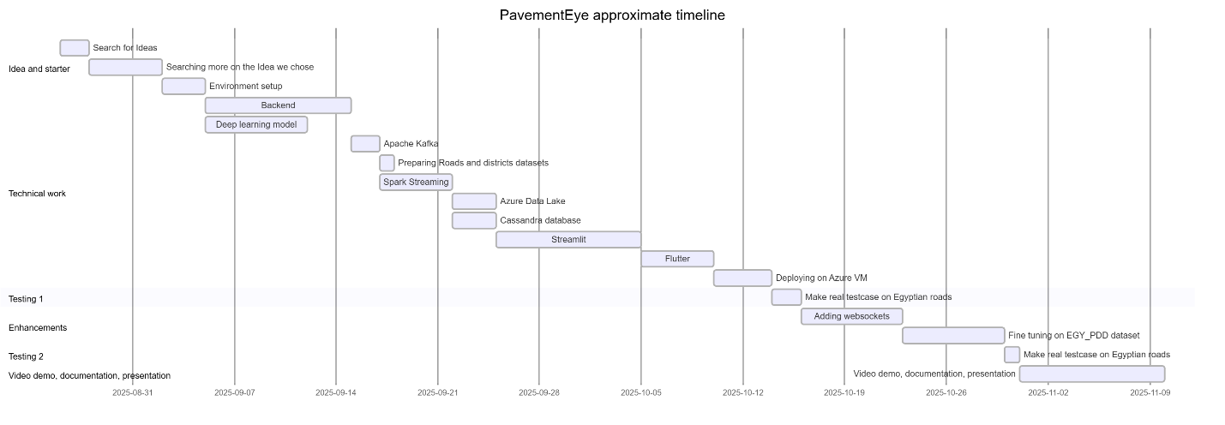

Team Actual Work and Roles
Name | Actual work done summary
Yahya | Team Leader, Data Engineering (Spark, Cassandra, kafka), Computer Vision (fine tuning on EGY_PDD dataset), Cloud Computing (Azure VM and Datalake and Huawei Cloud ECS and OBS), Backend Development and websocket connection, Flutter Development, Streamlit dashboard.
Salsabel | Apache Spark. Data visualization.
Rowan
Doaa | Flutter, Apache Spark.
Mohamed | Huawei Cloud, Data visualization and streamlit dashboard, helping in testcases, Video editing.

